**QUESTION #1**

*I only get the “UNKNOWN” directory under the “CRASHERS” directory. Is that OK? I wasn’t sure since it deviated from the YouTube tutorial for the CONVERT application.*

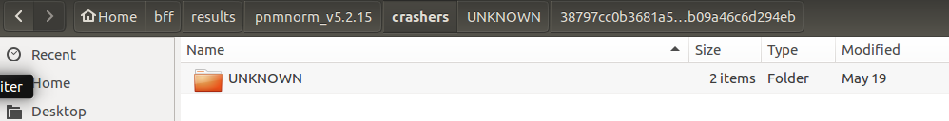

**QUESTION #2**

I only get a minimized file for 1 out of the 2 culpable campaigns (bytemut). For the DROP fuzz campaign it is not generating a minimized file. Am I doing something wrong?

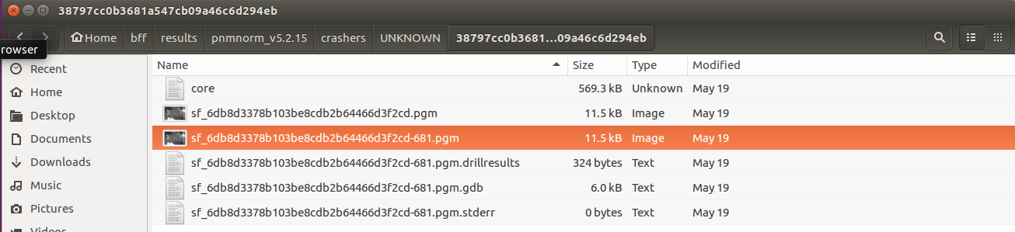

Figure : "Drop" Fuzz Campaign Output

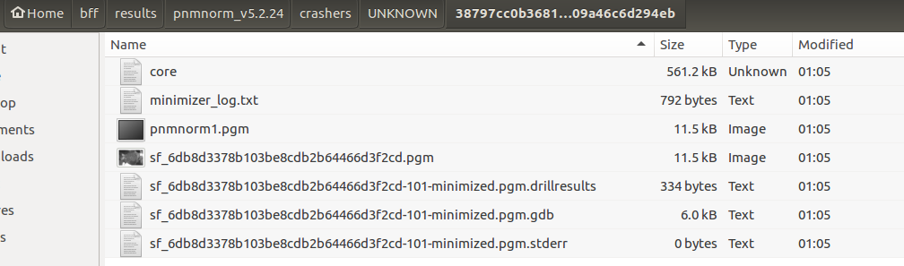

Figure : "ByteMut" Fuzz Campaign Output

**QUESTION #2**

Should I submit the .pgm file with the “-681” after it or the one without it?

